 

IMAGE COLORIZATION USING

DEOLDIFY ( GAN )

# PROJECT REPORT

***Submitted by***

**VENKATESH K (311521104062)**

***in fulfillment for the subject***

**NM1009 – GENERATIVE AI FOR ENGINEERING BACHELOR OF ENGINEERING**

***IN***

# COMPUTER SCIENCE AND ENGINEERING MEENAKSHI SUNDARARAJAN ENGINEERING COLLEGE,

**KODAMBAKKAM, CHENNAI-24**

**ANNA UNIVERSITY: CHENNAI 600 025**

# MAY 2024

ANNA UNIVERSITY: CHENNAI 600 025

**BONAFIDE CERTIFICATE**

Certified that this project report “**IMAGE COLORIZATION USING DEOLDIFY ( GAN )**” is the bonafide work of “**VENKATESH K (311521104062)** ” Naan Mudhalvan ID **“au311521104062”** who carried out the project work under my supervision.

**HOD SIGNATURE INTERNAL GUIDE SIGNATURE**

Dr.S.Aarthi,M.E.,Ph.D Mrs.P.Revathi ,M.Tech

**HEAD OF THE DEPARTMENT ASSISTANT PROFESSOR**

Computer Science and Engineering Computer Science and Engineering

Meenakshi Sundararajan Engineering College Meenakshi Sundararajan Engineering College

No. 363,Arcot Road, Kodambakkam, No.363, Arcot Road, Kodambakkam,

Chennai - 600024 Chennai - 600024

Submitted for the project viva voce of Bachelor of Engineering in Computer Science and Engineering held on .

# INTERNAL EXAMINER EXTERNAL EXAMINER

**ACKNOWLEDGEMENT**

First and foremost, we express our sincere gratitude to our Respected Correspondent **Dr. K. S. Lakshmi**, our beloved Secretary **Mr. N. Sreekanth**, Principal **Dr. S. V. Saravanan** for their constant encouragement, which has been our motivation to strive towards excellence.

Our primary and sincere thanks goes to **Dr. S. Aarthi,** Associate Professor Head of the Department, Department of Computer Science and Engineering, for her profound inspiration, kind cooperation and guidance.

We’re grateful to **Mrs P.Revathi** ,Internal Guide, Associate Professor Head of the Department as our project coordinators for their invaluable support in completing our project. We are extremely thankful and indebted for sharing expertise, and sincere and valuable guidance and encouragement extended to us.

Above all, we extend our thanks to God Almighty without whose grace and Blessings it wouldn’t have been possible.

# ABSTRACT

This project presents a sophisticated web application aimed at revolutionizing image colorization through the seamless integration of machine learning technologies. At its core lies the utilization of the DeOldify model, a state-of-the-art deep learning architecture revered for its unparalleled ability to transform black and white images into vividly colored masterpieces. The web application serves as a gateway for users to effortlessly upload grayscale images via a user-friendly interface, facilitating an immersive and intuitive experience. Leveraging the power of the DeOldify model, uploaded images undergo a complex process of colorization, where intricate details and nuances are meticulously preserved to deliver stunningly realistic results. The application's backend infrastructure orchestrates the interaction between the user interface and the DeOldify model, ensuring seamless communication and efficient processing of image data.

Through the application's interface, users gain access to a myriad of customization options, allowing them to fine-tune the colorization process according to their preferences. From adjusting color intensity to refining specific color palettes, users are empowered to tailor the output to suit their creative vision. Once the colorization process is complete, users can easily download the transformed images, enabling seamless integration with their personal and professional projects.

The project encapsulates a harmonious fusion of cutting-edge machine learning techniques and web development methodologies, employing technologies such as HTML, CSS, JavaScript, and backend frameworks to deliver a robust and scalable solution. By democratizing the process of image colorization, this project not only showcases the transformative potential of AI-driven technologies but also fosters a deeper appreciation for the intersection of art and technology in the digital age.

|  |  |  |
| --- | --- | --- |
|  | **TABLE OF CONTENTS** |  |
| **CHAPTER NO.** | **TITLE** | **PAGE NO.** |
|  | **ABSTRACT** | iv |
|  | **LIST OF TABLES** | vii |
| **1** | **INTRODUCTION** | **1** |
|  | 1.1 ABOUT THE PROJECT | 1 |
|  | 1.2 PROJECT OVERVIEW | 1 |
|  | 1.3 PURPOSE | 2 |
|  | 1.4 EXISTING SYSTEM | 2 |
|  | 1.5 PROBLEM STATEMENT | 4 |

1. LITERATURE SURVEY 5
2. SYSTEM ARCHITECTURE 7
   1. SYSTEM ARCHITECTURE 7
   2. HARDWARE REQUIREMENTS 8
   3. SOFTWARE REQUIREMENTS 8
      1. PYTHON 9
      2. FLASK 9

4. IDEATION 10

4.1 IDEATION & BRAINSTORMING 10

5. REQUIREMENT ANALYSIS 12

5.1 FUNCTIONAL REQIREMENTS 12

5.2 NON-FUNCTIONAL REQUIREMENTS 13

6. SYSTEM IMPLEMENTATION 14

6.1PROPOSED SYSTEM 14

6.2 SOURCE CODE 16

7. PROJECT DESIGN 20

7.1 USE CASE DIAGRAM 20

7.2 FLOW DIAGRAM 20

8. ADVANTAGES AND DISADVANTAGES 21

9. CONCLUSION AND FUTURE 23

ENHANCEMENT

9.1 CONCLUSION 23

9.2 FUTURE ENHANCEMENT 24

10. APPENDIX SCREENSHOT 26

# TABLE NO.

# LIST OF TABLES

# NAME OF THE TABLE

# PAGE NO.

* 1. HARDWARE REQUIREMENTS 8
  2. SOFTWARE REQUIREMENTS 8

# CHAPTER 1 INTRODUCTION

* 1. **ABOUT THE PROJECT**

This project is a web-based image colorization tool utilizing the DeOldify model, offering users a seamless interface to transform black and white images into vibrant color compositions. Through the integration of advanced machine learning techniques, the application accurately infuses grayscale images with rich, realistic colors, preserving intricate details and nuances. Users can effortlessly upload their images via an intuitive web interface and interact with customizable colorization settings to tailor the output to their preferences. The backend infrastructure orchestrates the processing pipeline, seamlessly integrating user input with the DeOldify model to ensure efficient and high-quality results. Leveraging web development technologies such as HTML, CSS, JavaScript, and backend frameworks, the project delivers a user-friendly and accessible platform for enthusiasts and professionals alike to explore the transformative capabilities of AI in image enhancement. From historical photographs to artistic creations, the application empowers users to revive and reimagine grayscale images, fostering a deeper appreciation for the intersection of technology and creativity in the digital landscape.

# PROJECT OVERVIEW

**Project Overview:** Image Colorization using Deoldify.

The project scope includes designing and implementing a web-based image colorization application using the DeOldify model. It encompasses creating an intuitive user interface for uploading grayscale images and customizing colorization settings. The application will integrate backend infrastructure to process user inputs and communicate with the DeOldify model for efficient colorization. Additionally, the scope involves ensuring compatibility across different devices and browsers for seamless user experience. Testing and refining the application's functionality and performance will be conducted to ensure reliability and scalability. The project aims to provide users with a robust platform for effortlessly transforming black and white images into vibrant, realistic compositions.

# PURPOSE

The primary purpose of this project is to address the challenge of image noise reduction while preserving important image features. The project seeks to explore the effectiveness of

convolutional autoencoders, a powerful deep learning technique, in removing noise from images. By developing a robust method for image denoising, the project aims to contribute to the advancement of image processing techniques and provide a valuable tool for researchers and practitioners in fields such as medical imaging, surveillance, and digital photography. Ultimately, the goal is to enhance image quality and facilitate accurate analysis and decision-making in various applications.

# EXISTING SYSTEM

**Architecture Overview:**

* The system uses a client-server architecture where the front-end (client side) interacts with a server-side backend to perform colorization tasks.
* The server utilizes the DeOldify model, a pre-trained deep learning model for automatic image colorization.

**Front-End Components:**

**User Interface (UI):**

A user-friendly interface built with modern web technologies (like HTML, CSS, and JavaScript frameworks such as React or Vue.js).

**File Upload:**

Users can upload their black-and-white images through a drag-and-drop interface or a traditional file browser.

**Colorization Controls**:

Basic settings for the colorization process, such as intensity or saturation.

**Preview and Download:**

Options to preview the colorized image and download the final output in various formats (like JPEG or PNG).

**Back-End Components:**

**API Endpoint:**

A RESTful API that handles incoming requests from the front-end. It includes an endpoint for uploading images and initiating colorization.

**DeOldify Model Integration:**

The DeOldify model runs on a server equipped with sufficient computational resources (such as a GPU) to perform the colorization task.

**Data Storage:**

A database or file storage system to manage uploaded images and colorized outputs, with considerations for data security and user privacy.

**Colorization Process:**

* The front-end sends the uploaded black-and-white image to the back-end.
* The back-end processes the image using the DeOldify model, applying machine learning techniques to add color.
* The resulting colorized image is returned to the front-end, where users can preview and download it.

# PROBLEM STATEMENT

The task is to develop a user-friendly web application that utilizes the DeOldify model for image colorization. The application should allow users to upload black and white images and generate realistic colorized versions using deep learning techniques. The primary challenge lies in implementing an efficient and accurate colorization algorithm, optimizing the user interface for seamless interaction, and ensuring compatibility across various web browsers and devices. Additionally, the project aims to address potential issues such as handling large image files, managing server-side resources, and maintaining data privacy and security. Overall, the goal is to create a robust and accessible solution that empowers users to effortlessly restore and enhance historical photographs and artworks through automated colorization technology. There is a need for a simple, user-friendly web application that automatically colorizes black-and-white images using advanced machine learning. The solution should provide high-quality results, customizable settings, and a seamless user experience, while also ensuring user privacy and data security.

# CHAPTER 2 LITERATURE SURVEY

**1. Background and Historical Context**

The practice of colorizing black-and-white images has a long history, traditionally done manually by artists and photographers. This manual process required significant time, skill, and effort. With the advancement of technology, automated methods began to emerge, offering a faster way to bring color to monochrome images.

**2. Early Approaches to Image Colorization**

Initially, image colorization involved heuristic-based methods, where specific rules were used to map grayscale values to colors. These early approaches, while pioneering, lacked the ability to produce realistic results and often relied on human intervention.

**3. Rise of Machine Learning and Deep Learning**

The introduction of machine learning, particularly deep learning, revolutionized image colorization. Models like Convolutional Neural Networks (CNNs) demonstrated significant potential in automating the colorization process. Key research in this area includes:

* Automatic Colorization Using CNNs: Early studies that explored using CNNs to learn from large datasets of colored images to predict colors for black-and-white images.
* Conditional Generative Adversarial Networks (cGANs): The use of GANs, where a generator and a discriminator work in tandem, showed improvements in generating realistic colorized images.

**4. DeOldify Model**

One of the most well-known models for image colorization is DeOldify, developed by Jason Antic. This model uses a deep learning approach, specifically based on cGANs, to achieve impressive results. DeOldify can automatically colorize black-and-white images with high quality, providing a robust solution for various applications.

5. Comparisons with Other Models

Various other models and techniques have been developed for image colorization, including:

* Pix2Pix: A popular method using cGANs for image-to-image translation, including colorization.
* ChromaGAN: A model that focuses on enhancing the realism of colorized images through a different approach to color prediction.
* Comparing these models, DeOldify stands out for its versatility and ability to handle a wide range of images, from historical photos to modern black-and-white artwork.

**6. Challenges and Limitations**

* Despite advancements, image colorization still presents challenges:
* Subjectivity in Color Choices: The "correct" color for certain elements in a black-and-white image can be subjective, leading to variations in results.
* Computational Requirements: Deep learning models require significant computational resources, especially for real-time colorization in a web application.
* User Experience and Customization: Balancing automation with user control is critical to create an application that appeals to a wide audience.

# CHAPTER 3 SYSTEM ARCHITECTURE

# SYSTEM ARCHITECTURE:

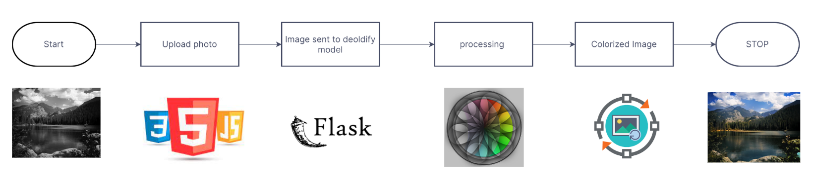

**Figure 3.1: System Architecture**

# HARDWARE REQUIREMENTS:

|  |  |
| --- | --- |
| **SYSTEM** | INTEL i3 Processor |
| **HARD DISK** | 256 GB |
| **MONITOR** |  |
| **INPUT DEVICES** | Keyboard, Mouse |
| **RAM** | 2 GB |

# SOFTWARE REQUIREMENTS:

|  |  |
| --- | --- |
| **REQUIREMENTS** | **SPECIFICATIONS** |
| TOOL | VS CODE |
| CODING LANGUAGE | PYTHON, HTML,CSS |
| OPERATING SYSTEM | WINDOWS 7 or higher |

# PYTHON:

Python is an interpreted, object-oriented, high-level programming language with dynamic semantics. Its high-level built-in data structures, combined with dynamic typing and dynamic binding, make it very attractive for Rapid Application Development, as well as for use as a scripting or glue language to connect existing components together. Python's simple, easy to learn syntax emphasizes readability and therefore reduces the cost of program maintenance. Python supports modules and packages, which encourages program modularity and code reuse. The Python interpreter and the extensive standard library are available in source or binary form without charge for all major platforms, and can be freely distributed.Top of Form

# FLASK:

Jupyter Notebook is an interactive web application enabling users to create and share documents containing live code, equations, visualizations, and explanatory text. Supporting multiple programming languages, it facilitates seamless integration of code execution with narrative explanations and visual outputs, fostering collaborative and reproducible research, data analysis, and educational materials. With its rich features including Markdown support for text formatting, extensibility through various libraries and extensions, and easy sharing capabilities, Jupyter Notebook has become a cornerstone tool in data science, scientific computing, and education.

# CHAPTER 4

**IDEATION AND BRAISTORMING**

**Research and Inspiration:** Conduct thorough research on existing image colorization techniques and technologies. Explore inspirational examples of colorized historical photographs and artworks to understand potential applications and user preferences.

**Identify User Needs:** Identify the target audience and their specific needs and preferences regarding image colorization. Consider the requirements of historians, photographers, educators, and general enthusiasts to ensure the solution addresses a diverse range of use cases.

**Feature Prioritization:** Brainstorm and prioritize features based on their feasibility, relevance, and potential impact on user experience. Consider features such as intuitive user interface design, customization options, batch processing capabilities, and integration with social media platforms.

**Technical Considerations:** Evaluate the technical requirements and challenges associated with implementing image colorization using deep learning models. Consider factors such as model selection, training data, computational resources, and deployment infrastructure.

**Iterative Prototyping:** Develop iterative prototypes or mockups to visualize and refine the user interface and functionality of the colorization application. Solicit feedback from stakeholders and potential users to iteratively improve the design and usability of the solution.

**Experimentation and Exploration:** Encourage creative experimentation and exploration of novel ideas and approaches to image colorization. Consider incorporating advanced techniques such as style transfer, semantic segmentation, or attention mechanisms to enhance colorization quality and realism.

**Collaboration and Feedback:** Foster collaboration and brainstorming sessions with team members, domain experts, and stakeholders to generate new ideas and perspectives. Seek feedback from potential users through surveys, interviews, or usability testing to validate and refine the ideated concepts.

**Iterative Development:** Adopt an iterative development approach, where ideas are continuously tested, refined, and validated through prototyping, feedback gathering, and iteration cycles. Embrace flexibility and openness to pivot or adjust the direction of the project based on insights gained during the ideation and brainstorming process.

# CHAPTER 5 REQUIREMENT ANALYSIS

The requirements analysis phase involves identifying and specifying the functional and non-functional requirements of the image noise reduction project. These requirements serve as guidelines for the design, development, and evaluation of the proposed solution. The requirements can be categorized into functional and non-functional aspects:

# FUNCTIONAL REQUIREMENTS

* **Image Upload:** Users should be able to upload black and white images in common formats such as JPEG, PNG, and GIF.
* **Colorization Process:** The system should initiate the colorization process upon image upload, applying the DeOldify model to generate colorized versions of the input images.
* **Customization Options:** Users should have the option to customize colorization settings, including saturation, contrast, brightness, and color palette selection.
* **Real-Time Preview:** The system should provide a real-time preview of the colorized image, allowing users to visualize the transformation and make adjustments if necessary.
* **Batch Processing:** Users should be able to submit multiple images for colorization simultaneously, with the system processing each image in parallel to optimize efficiency.
* **Download and Save:** Users should have the option to download and save the colorized images in common formats for further use and sharing.
* **Error Handling:** The system should handle errors gracefully, providing informative error messages and guidance to users in case of invalid inputs or processing failures.

# NON-FUNCTIONAL REQUIREMENTS

* **Performance**: The system should deliver colorization results quickly and efficiently, with minimal processing time and resource utilization.
* **Accuracy:** The colorized images should accurately represent the original scenes, with realistic and faithful colorization results that preserve details and nuances.
* **Scalability:** The system should be scalable to accommodate a large number of concurrent users and image processing requests without degradation in performance.
* **Usability:** The user interface should be intuitive and easy to navigate, with clear instructions and visual cues to guide users through the colorization process.
* **Compatibility:** The system should be compatible with a wide range of web browsers and devices, ensuring accessibility for users on different platforms and screen sizes.
* **Security:** The system should implement security measures to protect user data and ensure the confidentiality and integrity of uploaded and processed images.
* **Reliability**: The system should be reliable and robust, with mechanisms in place to handle failures gracefully and recover from errors without data loss or service interruptions.

**CHAPTER 6**

**SYSTEM IMPLEMENTATION**

# PROPOSED SYSTEM

Our proposed solution is a user-friendly web application that harnesses the power of deep learning to provide seamless and high-quality colorization of black and white images. The core of our solution is the integration of the DeOldify model, a cutting-edge deep learning architecture specifically designed for image colorization tasks.

**KEY FEATURES:**

**Intuitive User Interface:** We prioritize user experience by designing an intuitive and user-friendly interface that allows users to effortlessly upload black and white images and initiate the colorization process with minimal effort.

**Real-Time Colorization:** Our solution offers real-time colorization capabilities, enabling users to visualize the transformation of their images instantly and make adjustments as needed before finalizing the colorized versions.

**Customization Options**: To cater to diverse preferences and requirements, we provide customization options that allow users to adjust colorization settings, such as saturation, contrast, and brightness, to achieve the desired aesthetic.

**Batch Processing:** For users with large collections of black and white images, our solution supports batch processing, allowing multiple images to be colorized simultaneously for efficient and streamlined workflow.

**Quality Assurance:** We implement quality assurance measures to ensure the accuracy and realism of colorized images, including validation checks and user feedback mechanisms to continuously improve the colorization results.

**Compatibility and Accessibility**: Our solution is designed to be compatible with various web browsers and devices, ensuring accessibility for users across different platforms and environments.

**Value Proposition:**

**Efficiency:** Our solution simplifies the colorization process, saving users time and effort compared to manual editing or traditional software tools.

**Accuracy:** Leveraging advanced deep learning techniques, our solution delivers precise and realistic colorizations that faithfully capture the essence of the original black and white images.

**Versatility:** With customizable settings and batch processing capabilities, our solution caters to a wide range of user needs and use cases, from historical restoration to artistic expression.

**Engagement:** By enabling users to revive and share historical images in vibrant color, our solution fosters engagement, curiosity, and appreciation for visual storytelling and cultural heritage.

# SOURCE CODE :

from flask import Flask, request, send_file,send_from_directory

from flask_cors import CORS

from PIL import Image

from util import ColorizeTheImage

import io

import os

import tempfile

app = Flask(__name__)

CORS(app) # Enable CORS for all routes

# works fine below

@app.route('/process-image', methods=['POST'])

def process_image():

file = request.files['image']

# Save the uploaded file to a temporary file

file.save("test_images/inputs/input.jpeg")

img_out = ColorizeTheImage("test_images/inputs/input.jpeg")

img_out.save("test_images/ouputs/output.jpg")

output_image = Image.open("test_images/ouputs/output.jpg")

byte_io = io.BytesIO()

output_image.save(byte_io, 'PNG')

byte_io.seek(0)

return send_file(byte_io, mimetype='image/png')

@app.route('/inputImage')

def get_input():

directory_path = 'test_images/inputs'

return send_from_directory(directory_path, 'input.jpeg', mimetype='image/jpeg')

@app.route('/outputImage')

def get_output():

directory_path = 'test_images/ouputs'

return send_from_directory(directory_path, 'output.jpg', mimetype='image/jpeg')

if __name__ == "__main__":

app.run(debug=True)

Setup.py:

from setuptools import setup, find_packages

def get_description():

return "Deep Learning library for colorizing and restoring old images and video"

def get_requirements():

with open("requirements.txt") as f:

return f.read().splitlines()

setup(

name="DeOldify",

version="0.0.1",

packages=find_packages(exclude=["tests"]),

url="https://github.com/jantic/DeOldify",

license="MIT License",

description=get_description(),

classifiers=[

"Development Status :: 4 - Beta",

"Framework :: Jupyter",

"Intended Audience :: Developers",

"Intended Audience :: Science/Research",

"License :: OSI Approved :: MIT License",

"Programming Language :: Python :: 3.6",

"Programming Language :: Python :: 3.7",

"Topic :: Scientific/Engineering :: Artificial Intelligence",

"Topic :: Software Development :: Libraries :: Python Modules",

],

install_requires=get_requirements(),

python_requires=">=3.6",

)

Util.py:

import torch

from deoldify import device

from deoldify.device_id import DeviceId

from deoldify.visualize import *

torch.backends.cudnn.benchmark = True

def ColorizeTheImage(source):

device.set(device=DeviceId.CPU)

colorizer = get_image_colorizer(artistic=True)

img_out = colorizer.get_transformed_image(path=source,

render_factor=15,

watermarked=False)

print(type(img_out))

print(img_out)

img_out.save("test_images/ouputs/output.jpg")

print("Done")

return img_out

­­­­­­­­­­­­­­­­­

**CHAPTER 7 PROJECT DESIGN**

# USE CASE DIAGRAM:

# 

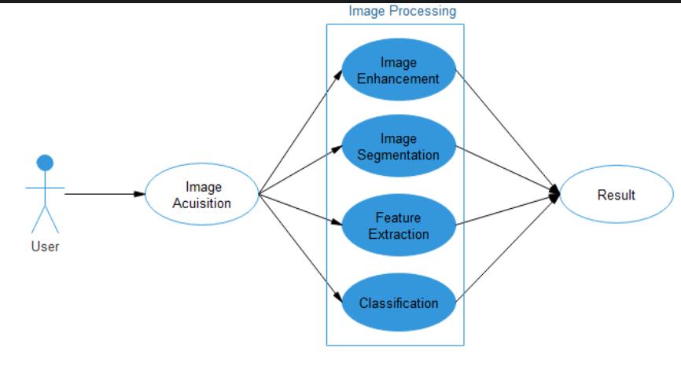

# FLOW DIAGRAM:

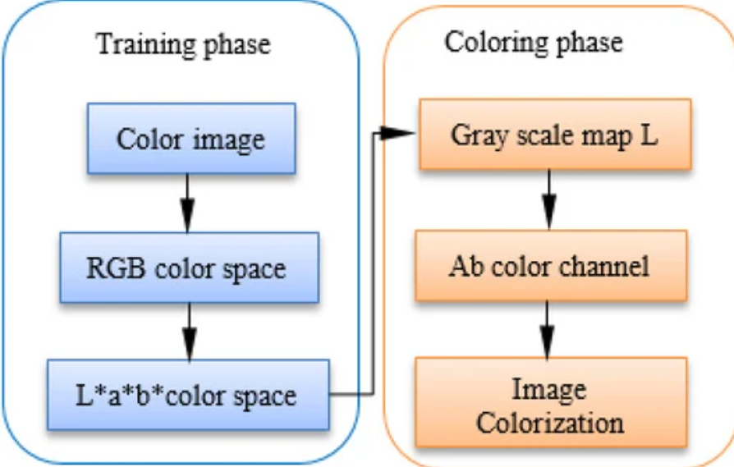

**CHAPTER 8**

**ADVANTAGES AND DISADVANTAGES**

* 1. **ADVANTAGES**

1. **Realistic Colorization:** The application utilizes advanced deep learning techniques to generate realistic and high-quality colorizations of black and white images, enhancing visual appeal and preserving historical context.
2. **User-Friendly Interface:** With an intuitive and easy-to-use interface, the application enables users to effortlessly upload images and customize colorization settings, making it accessible to users with varying levels of technical expertise.
3. **Customization Options:** Users have the flexibility to adjust colorization settings such as saturation, contrast, and brightness, allowing for personalized and creative interpretations of grayscale images.
4. **Batch Processing:** The application supports batch processing, enabling users to colorize multiple images simultaneously, saving time and effort when working with large collections of images.
5. **Historical Restoration:** By colorizing historical photographs and artworks, the application revitalizes and preserves cultural heritage, fostering a deeper connection and appreciation for the past.

# DISADVANTAGES

1. **Accuracy Limitations:** Despite advancements in deep learning technology, the application may encounter challenges in accurately colorizing certain types of images, particularly those with complex textures, patterns, or lighting conditions.
2. **Resource Intensive:** The colorization process can be computationally intensive, requiring substantial computational resources and time, especially for high-resolution images or large batch processing tasks.
3. **Subjectivity in Colorization:** Colorization is inherently subjective, and the application's automated algorithms may not always produce colorizations that align with users' preferences or artistic interpretations.
4. **Dependency on Training Data:** The accuracy and performance of the colorization model are heavily reliant on the quality and diversity of the training data used to train the deep learning algorithms, which may impact the application's effectiveness across different image types and genres.
5. **Privacy Concerns:** Users may have concerns about the privacy and security of their uploaded images, particularly when using cloud-based services or sharing sensitive historical photographs or personal artworks. Ensuring robust data protection measures and transparent privacy policies is essential to address these concerns.

**CHAPTER 9**

**CONCLUSION AND FUTURE ENHANCEMENT**

# CONCLUSION

# The development of a web application that uses the DeOldify model for automatic image colorization represents a significant advancement in bridging the gap between historical black-and-white images and modern color imagery. By leveraging advanced machine learning techniques, this project offers a user-friendly platform that allows users to transform monochrome images into vibrant, lifelike compositions with ease.

# Throughout this project, we have focused on creating an intuitive user experience, ensuring that users of all technical skill levels can seamlessly upload, colorize, and download their images. The implementation of a flexible backend with a robust model like DeOldify has enabled high-quality colorization, while the front-end's simple interface makes the application accessible and enjoyable to use.

# As we look to the future, there are many opportunities for enhancement, from improved colorization accuracy to expanded functionality like batch processing, mobile integration, and advanced user customization. The inclusion of features like social media integration, user accounts, and community collaboration can also contribute to a richer user experience and foster a sense of community around the application.

# In conclusion, this web application demonstrates the potential of machine learning in bringing new life to historical and personal images. It provides a valuable tool for users to relive memories and appreciate the beauty of colorization in a modern context. By continuing to innovate and incorporate user feedback, the project can grow and remain a relevant and engaging platform for years to come.

# 9.2 FUTURE ENHANCEMENT:

The following are possible future enhancements for a web application that uses the DeOldify model for image colorization. These enhancements aim to improve functionality, performance, user experience, and scalability:

1. **Enhanced Colorization Models**: As machine learning technology evolves, consider incorporating new and improved colorization models. This could involve using more advanced deep learning architectures or pre-trained models that provide even greater accuracy and color fidelity.
2. **User Customization and Control**: Implement features that allow users to control specific aspects of the colorization process. This could include sliders to adjust color intensity, contrast, or other visual parameters, giving users more flexibility in achieving desired results.
3. **Batch Processing and Automation:** Add support for batch processing, allowing users to upload and colorize multiple images simultaneously. Automation features could enable scheduled colorization tasks or integration with other services, like cloud storage platforms, to streamline workflows.
4. **User Accounts and Personalization**: Introduce user accounts to enable personalized experiences, allowing users to save colorized images, track their colorization history, and create personal galleries. This would also facilitate the implementation of social features, like sharing colorized images within a user community.
5. **Performance Optimization and Scalability:** Optimize the backend infrastructure to improve performance, reduce processing times, and handle increased user demand. This could involve implementing caching mechanisms, load balancing, or distributed computing to ensure scalability.
6. **Mobile App Integration**: Develop a mobile application to extend the web app's functionality to mobile devices. This would allow users to colorize images on the go, with seamless integration between the mobile app and the web platform.
7. **Social Media Integration:** Integrate the application with popular social media platforms, allowing users to share colorized images directly from the web application. This would increase user engagement and expand the reach of the platform.
8. **Accessibility Features:** Implement accessibility features to ensure the web application is usable by a broader audience, including those with visual impairments or other disabilities. This could involve support for screen readers, keyboard navigation, and high-contrast themes.
9. **Advanced Security Measures:** Enhance the security of the web application to protect user data and prevent unauthorized access. This could include additional encryption for data storage and transmission, as well as multi-factor authentication for user accounts.
10. **Community and Collaboration Tools**: Create a community space within the application where users can collaborate, share tips, and discuss their experiences with colorization. This could foster a sense of community and encourage user-generated content.

By implementing these future enhancements, the web application can continue to evolve, offering new features and improved performance while providing a superior user experience. These improvements can help the application remain competitive and appealing to a wide range of users.

# APPENDIX SCREENSHOTS

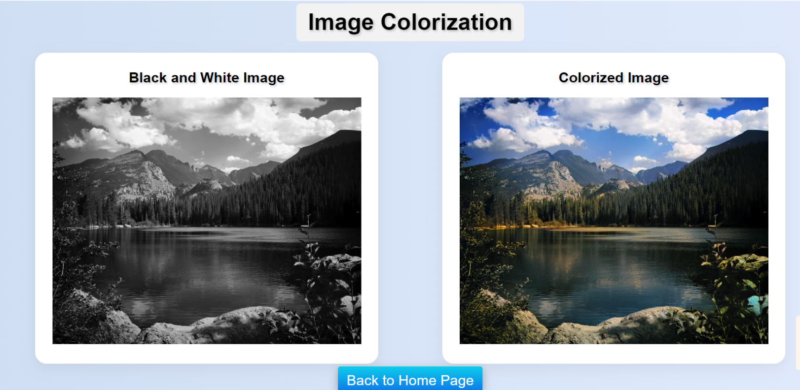

**REFERENCES:**

## Deoldify Model

<https://deoldify.ai/>

**GITHUB LINK:** <https://github.com/venkatesh1220/GenAI>

**COMPLETION CERTIFICATE :**

